TWOJE MINIBROWARY Sp. z o.o.

- BCGF16-12-6 Washing Filling Capping 3in1 Machine
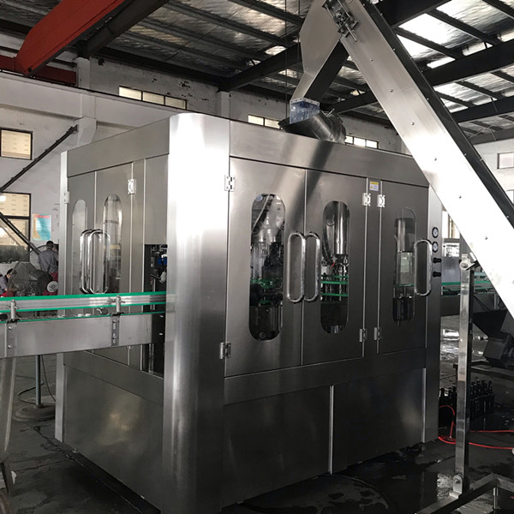
Detailed picture
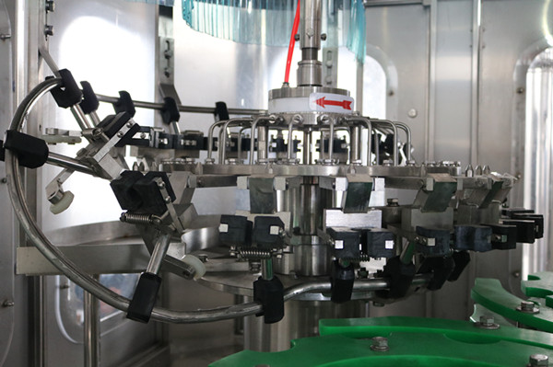 | Washing part  (screw dispenser glass bottle ,stainless steel water distribute pipe )
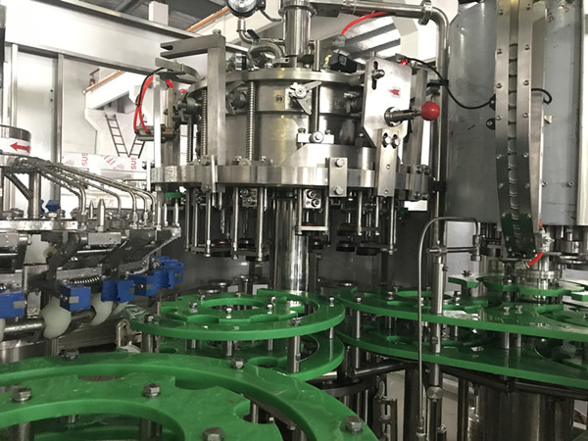 | Washing/filling/capping Part
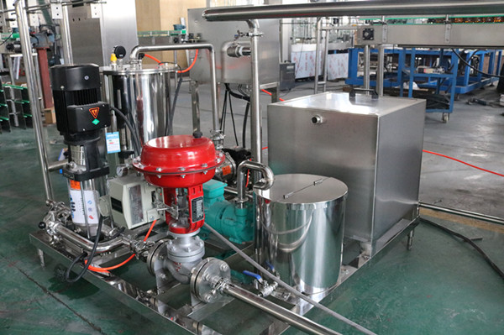 | Foam device
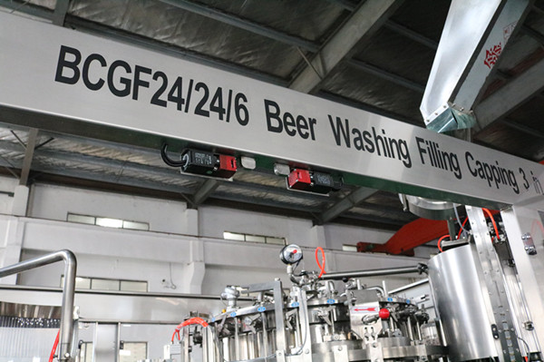 | door with auto-shutdown protection device
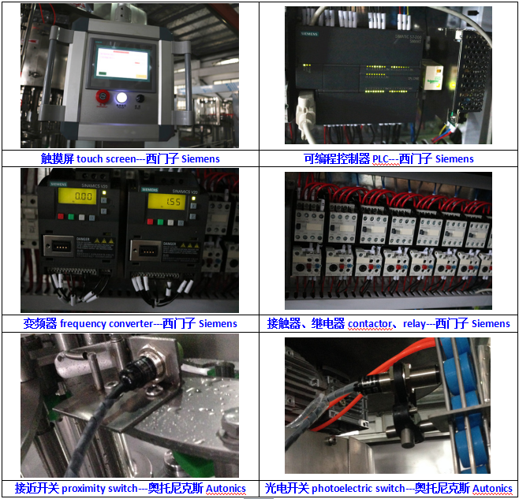 | Electric control box  - PLC:SIEMENS  - Touch Screen : SIEMENS  - A/C Contactor : SIEMENS  - Gas tank : AIRTAC  - Photoelectric switch : Autonics
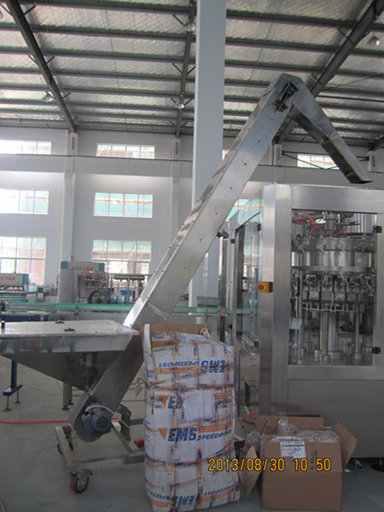 | Cap elevator  (belt type)
Usage
It is used for filling and sealing various kinds of glass bottle with crown type bottle mouth for beer filling producing line.
The machine is adopted the advanced international technology. It is design scientific and reasonable, appearance is beautiful, operation and maintenance is convenient, and it is high degree for automatization, so it is the good machine for choosing by beer filling factory.
Structural Features
1, The rinsing machine using high-strength stainless steel bottles of spring-loaded folders, to ensure a stable reversal of the glass bottles. The nozzle is a plum-like structure can wash every corner of the sidewall and bottom to make the bottle clean.
2, Filling machine with spring-type mechanical lifting equipment to upgrade glass bottles, large bearing support floundering in the vat and use of guide-rod in the orientation of the structure, there are pre-cover features.
3, Using high-precision mechanical filling valve, with cylinder liquid level and the back pressure controlled by a variable signal proportional. Fast, stable, accurate, to be vacuum two time.
4, Stainless steel plunger and mechanical stirring gland-type magnetic reasonable cap to ensure that the gland is healthy and reliable. Hopper and the cap taking- cover, capping transmitted by magnetic. The capping is reliable and automatic unloading, reducing the rate of broken bottles.
5, Before capping, using hot water bubble settings to displace bottlenecks air, ensuring the oxygen content of less than 0.15mg / L.
6, Filling machines includes broken bottle automatically stopping valve, broken bottle washing, and foam automatically exhausting device.
7, With perfect CIP cleaning function, and capable of rinsing filling pipes with acid, lye liquid or hot water.
All the materials contacted with the valves, tanks, pipes are made of stainless steel N304 materials, inside and outside of the wall are mirror-polished, ensuring non- insanitary sites.
8, Manually dry oil lubrication system to make sure equipment maintenance more convenient.
9, The whole operation adopts advanced man-operational interface, PLC control, frequency conversion stepless speed regulation and other automatic control technology, with no bottle no open valves, no stamps; no caps no operation, and other security protection.
Main technical parameters
Model : BCGF16-12-6
Capacity: 400-500 BPH (double vacuum)
Glass bottle standard: Bottle diameter ø50-ø85
Bottle height 105-280mm
Suitable cap shape: Crown cover
cap unscramble power: 0.18kw
Main Power:2.2KW
Dimension: 2300*1850*2200MM
Weight: 2500KG

- Rotary empty bottle input table
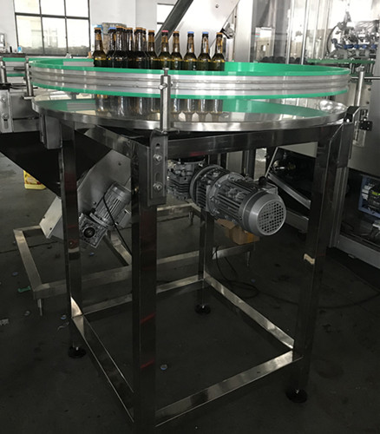

- Adhesive labeling machine (one label)
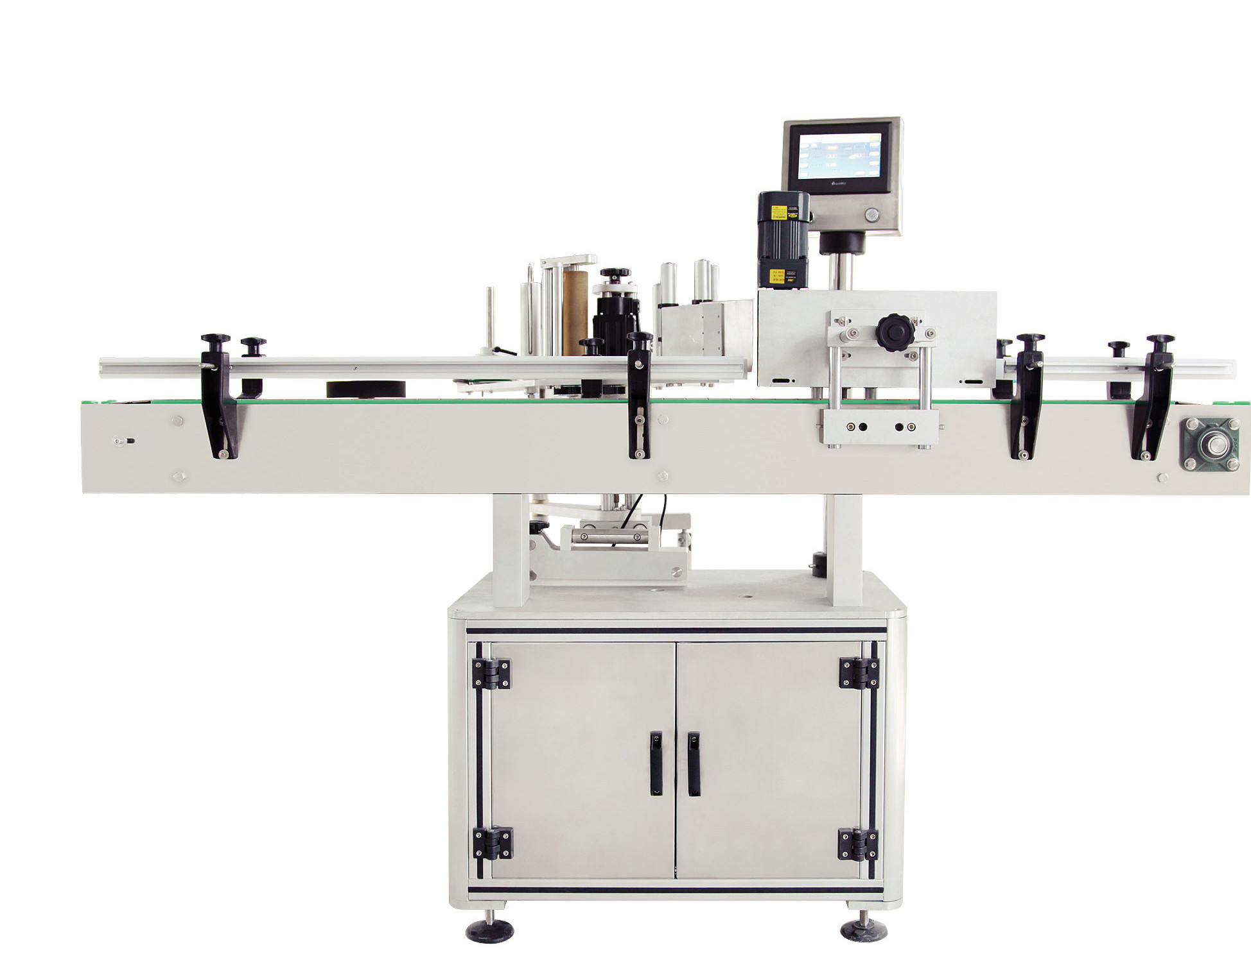
This machine is suitable for round bottle to label, control system adopted Panasonic stepper two-axis PLC control, collocation large LCD human interface, it is easily to operate, servo motor control label. This machine is made of SUS304 and aluminum alloy to meet GMP standards.
Labeling speed is synchronized with conveyor speed track, can be used with 650mm diameter turntable automatically into the bottle, optional hot foil printer.
Standard score better bottle wheel for roundness and labeling speed is less than 80 of bottles per minute.
Separating screw labeling speed per minute for more than 80 bottles or more bottles and standing firm.
Main technical parameters
Label height | 30-250mm
Label length | 30-300mm
Diameter of bottle body | 30-300mm(large size products, conveyor  belts can be customized)
Label roll inner diameter | 76mm
Label roll outer diameter | ≤360mm
Speed | 12-38 meters/min
Dimension | L2000 * W1130 * H1530mm
Weight | Approx 300kg

- Bottle collection table
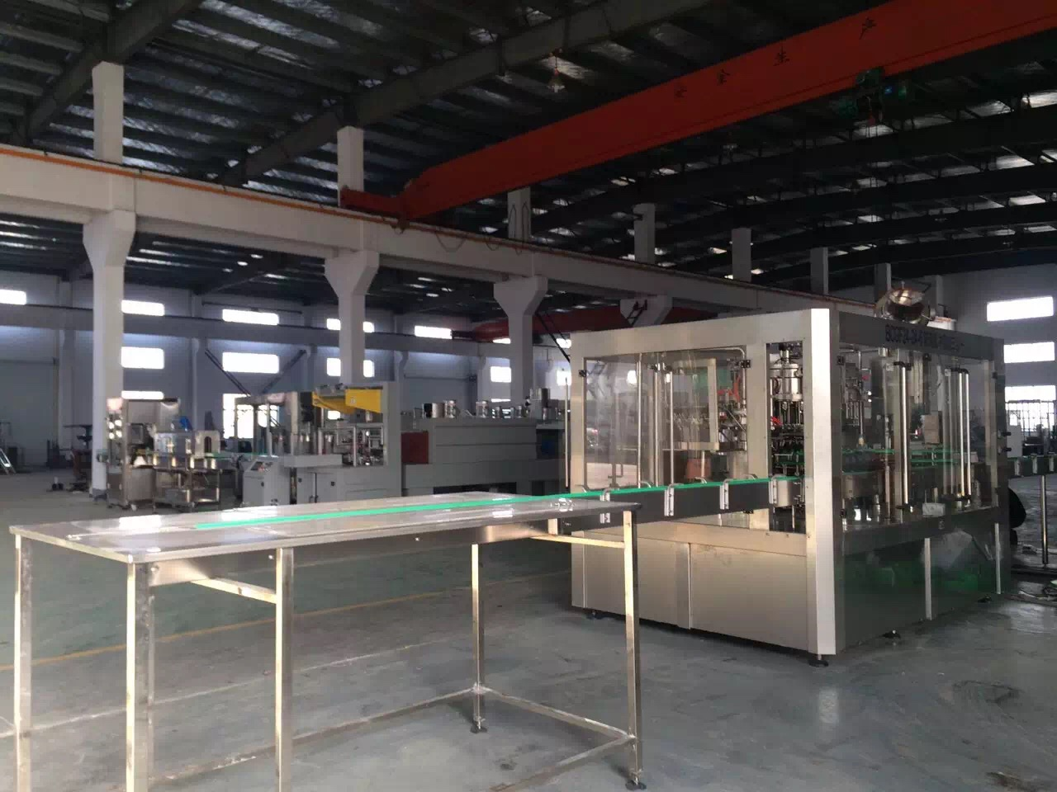

- Price list
Num | name | Type | unit | price  USD | remark
1 | Glass Bottle Beer washing/filling/ capping machine | BCGF 16-12-6 | 1set | 38400
2 | Foam device |  | 1set | 38400
3 | Conveyor | SS-A | 4m | 38400 | Bottle input 2m,output 2m
4 | Light check | DJ-A | 1set | free
5 | Cap elevator | SGJ-1 | 1set | 3720 | For delivery crown cap
6 | Rotary empty bottle input table | JP-A | 1set | 2160
7 | Adhesive labeling machine | TB-510B | 1set | 9600 | One label
8 | Bottle collection table | 2000*900mm | 1set | 1560
TOTAL PRICE USD 55440.00 nettoFOB GDANSK PORT

- Terms & Conditions:
1. Validity of offer : 30days
2. Terms of Payment:50 % of total value paid by T/T as down payment; Balance of 40% total value will be paid by T/T before shipping.;10% after delivery to the recipient
3. Date of Shipment:45 working days after we receive your payment and your bottle’s samples and caps.
4. Installation and commission: If the buyer needs seller’s technician to install and commission machines in his country, he shall afford a round trip airlines tickets, lodging and board and transportation and other insurance for seller’s technician. In the period of installation & debugging, the fee of installation and debugging is free, however the buyer should pay 100US dollar per day for each technician as allowance .
- Guarantee: The guarantee period will be 12 months after delivery.
6. Packing: Standard export Packing of wooden case.

